**Week12 – InClassActivity**

**Student Name: Renuka Rijal**

**Student Id: 200584442**

**Prof. Goutham Aduri**

**Due Date: 2024-11-20 (03:00 pm)**

1. **Pokémon Card Generator**

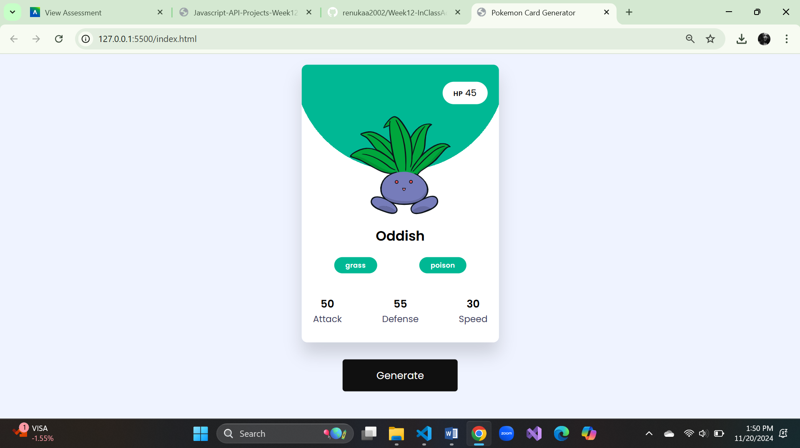

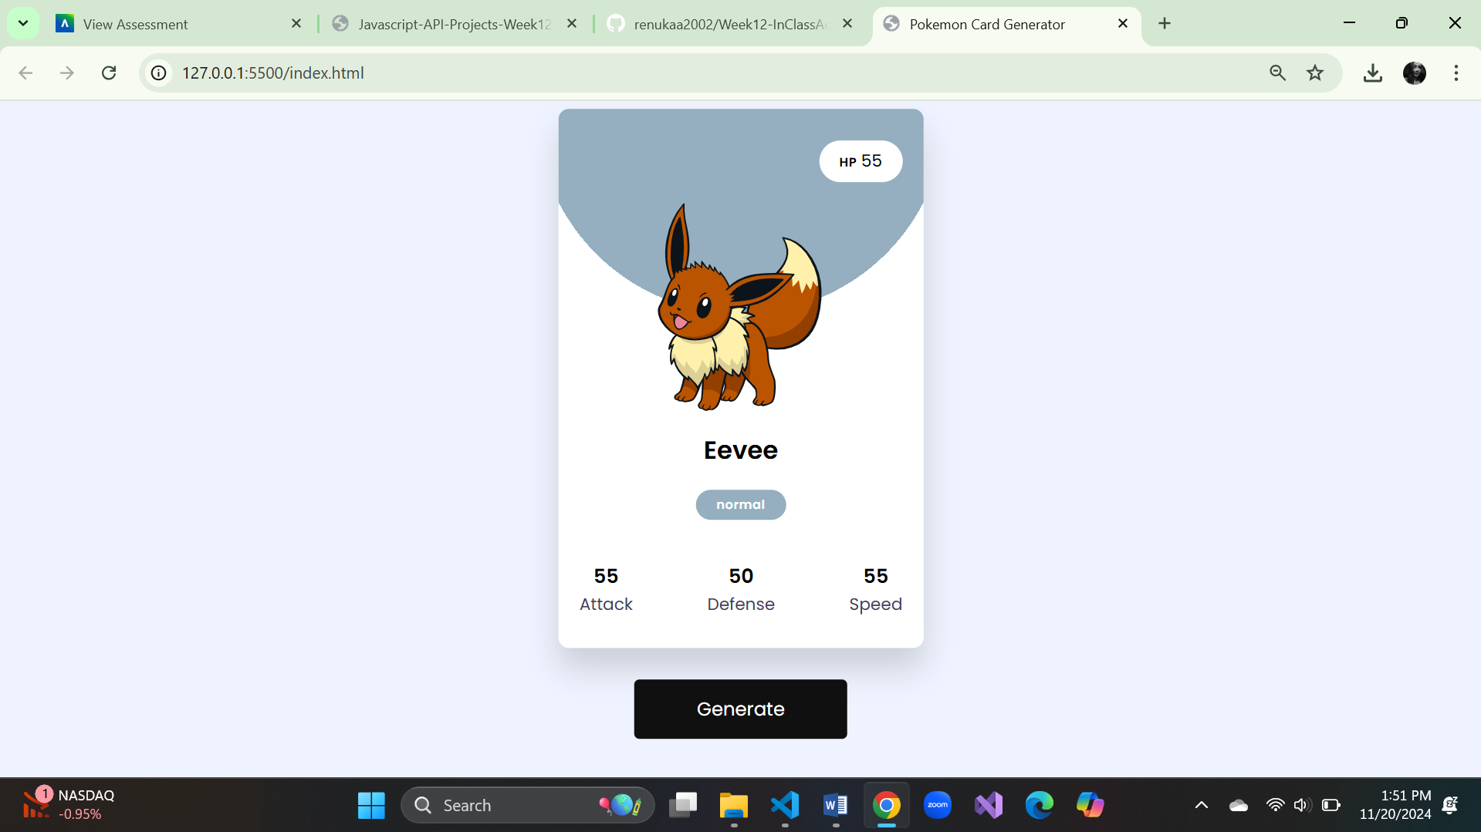

1. **Country Guide App**

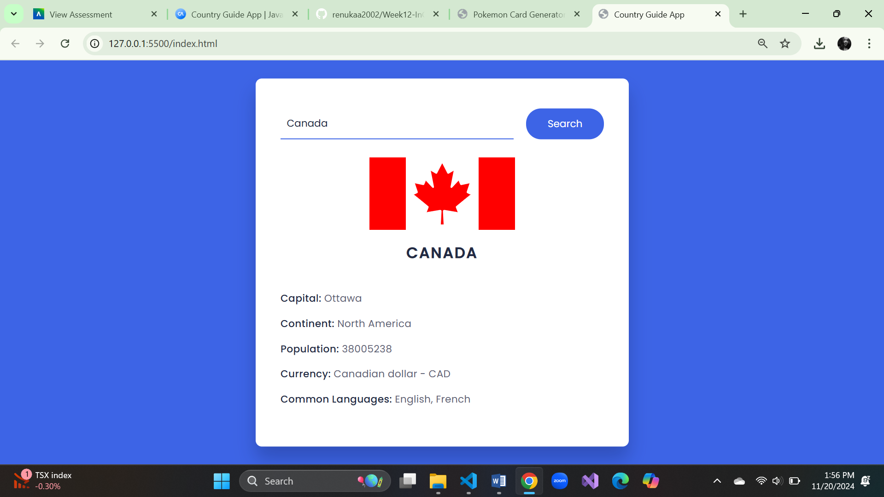

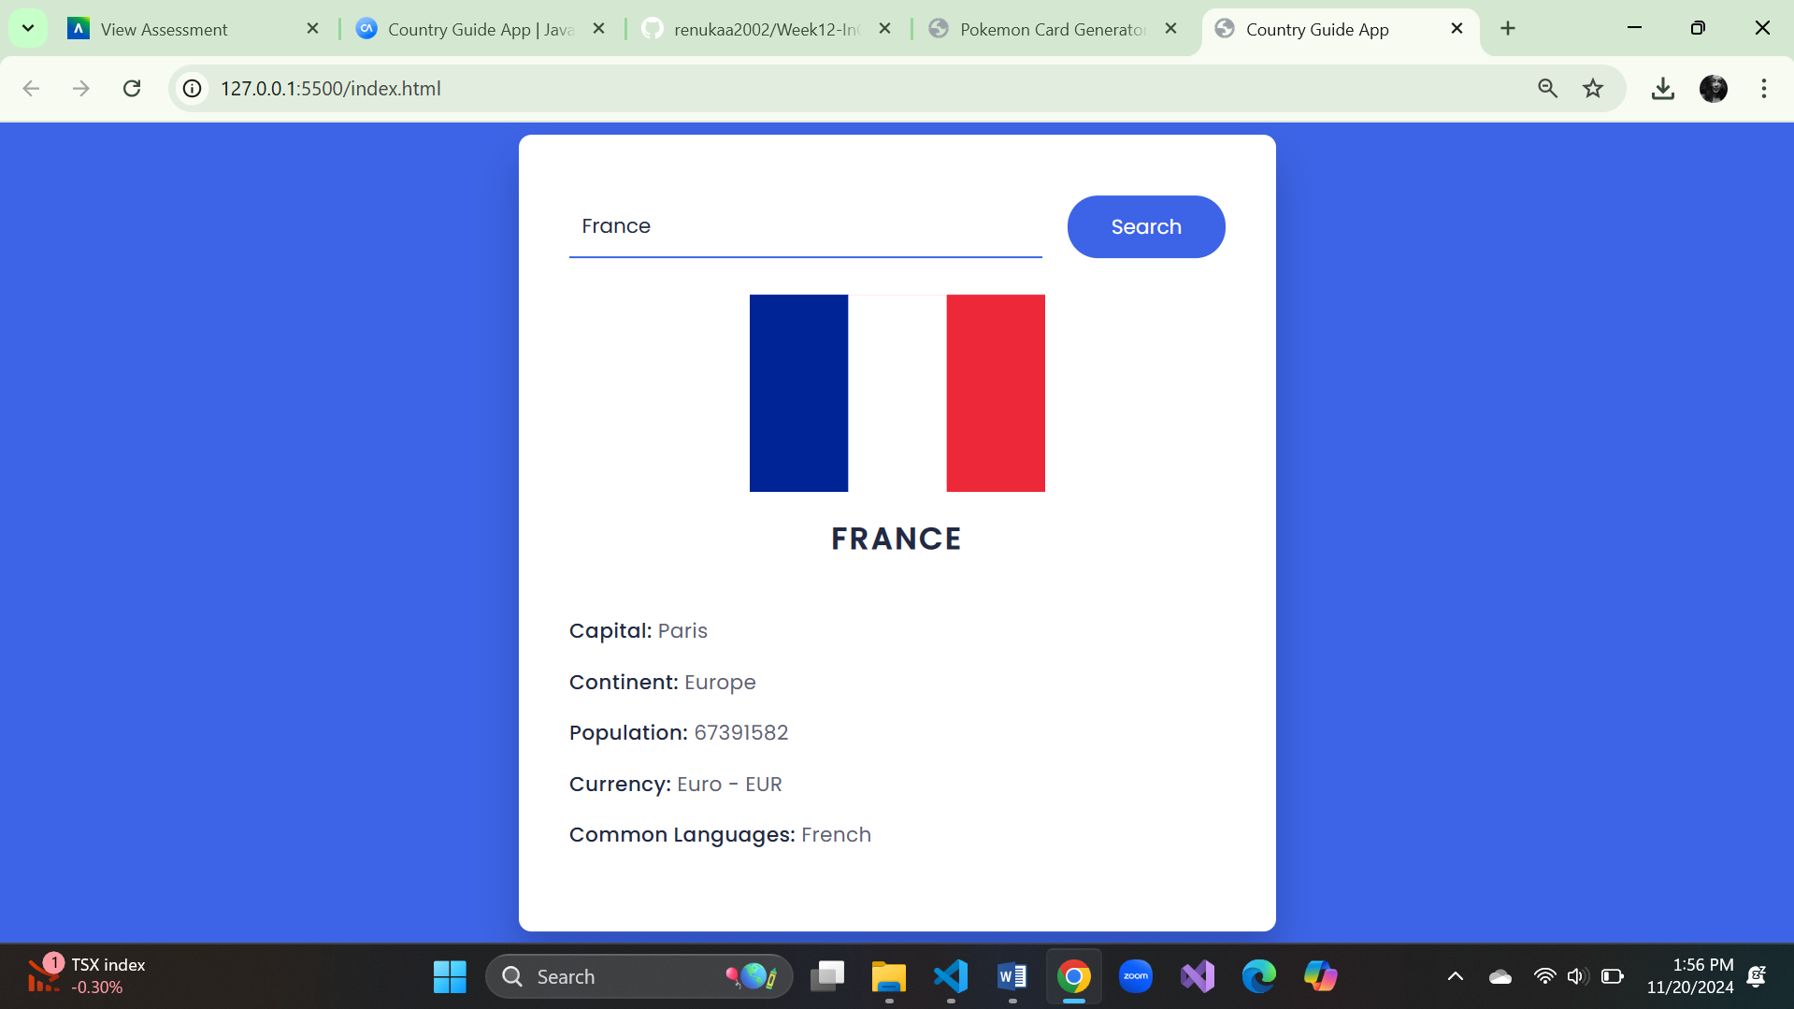

1. **Recipe App**

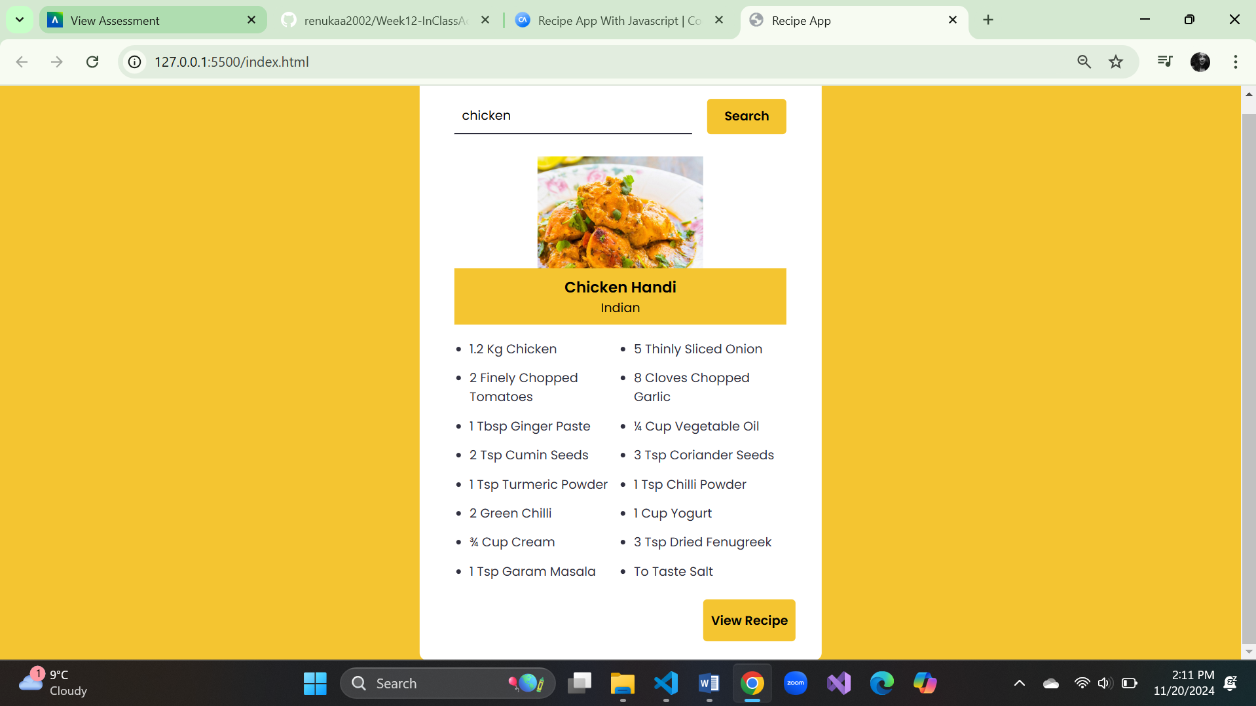

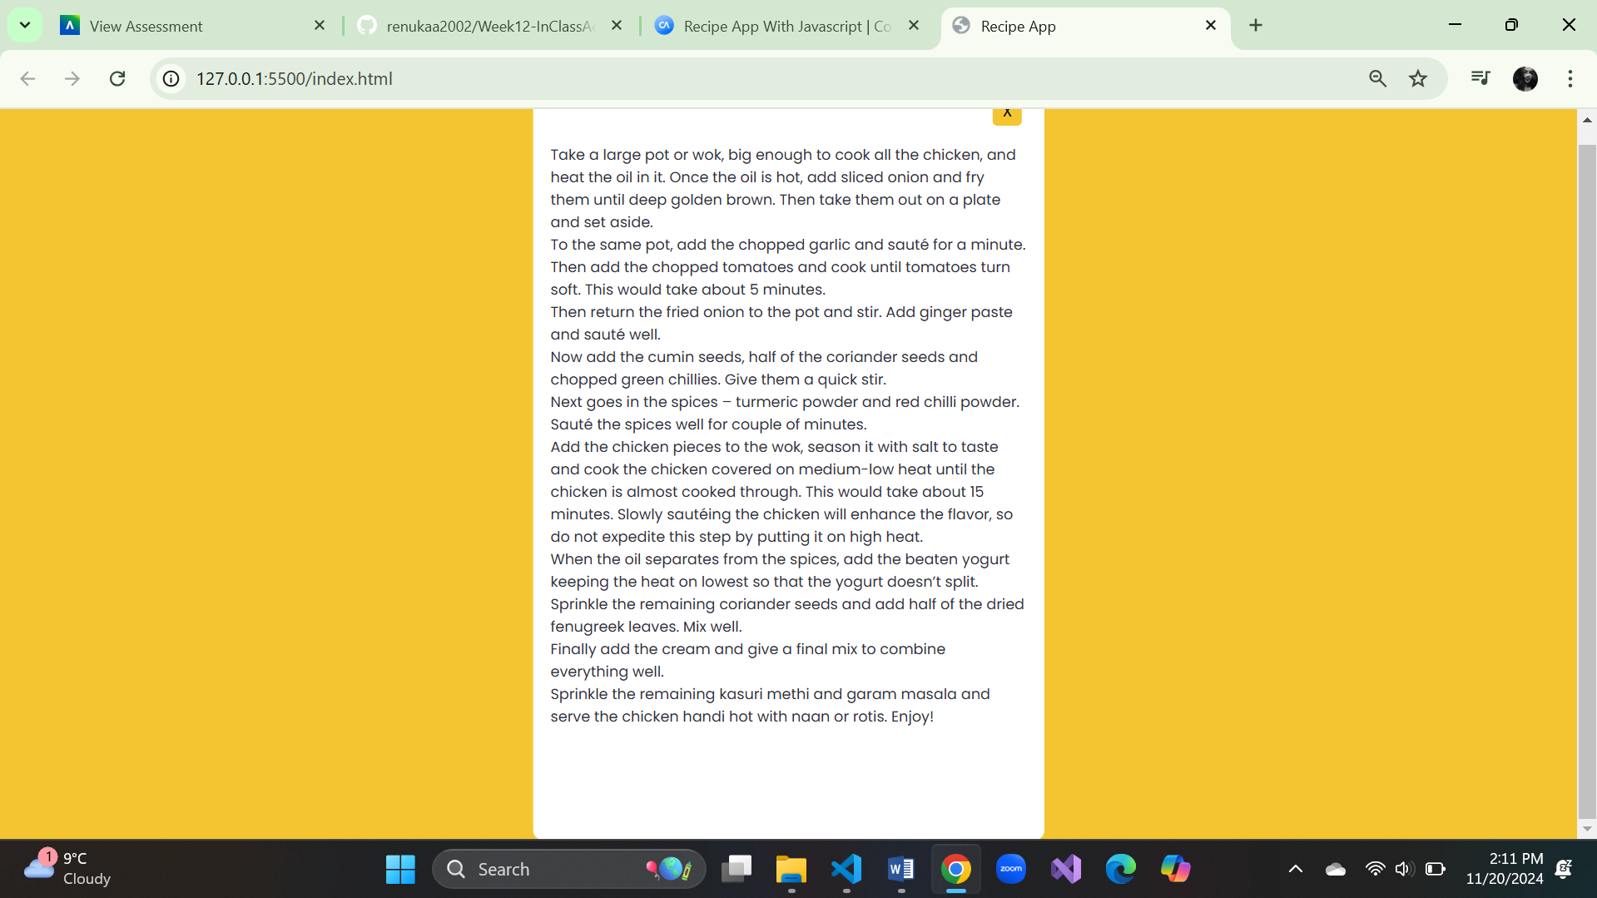

1. **Movie App**

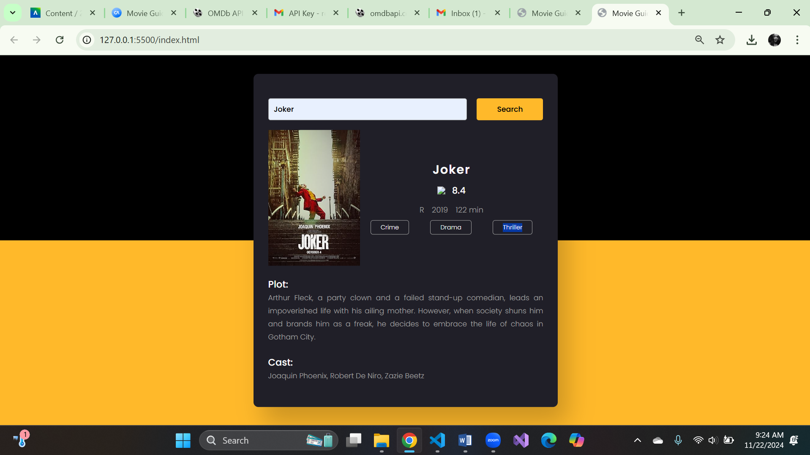

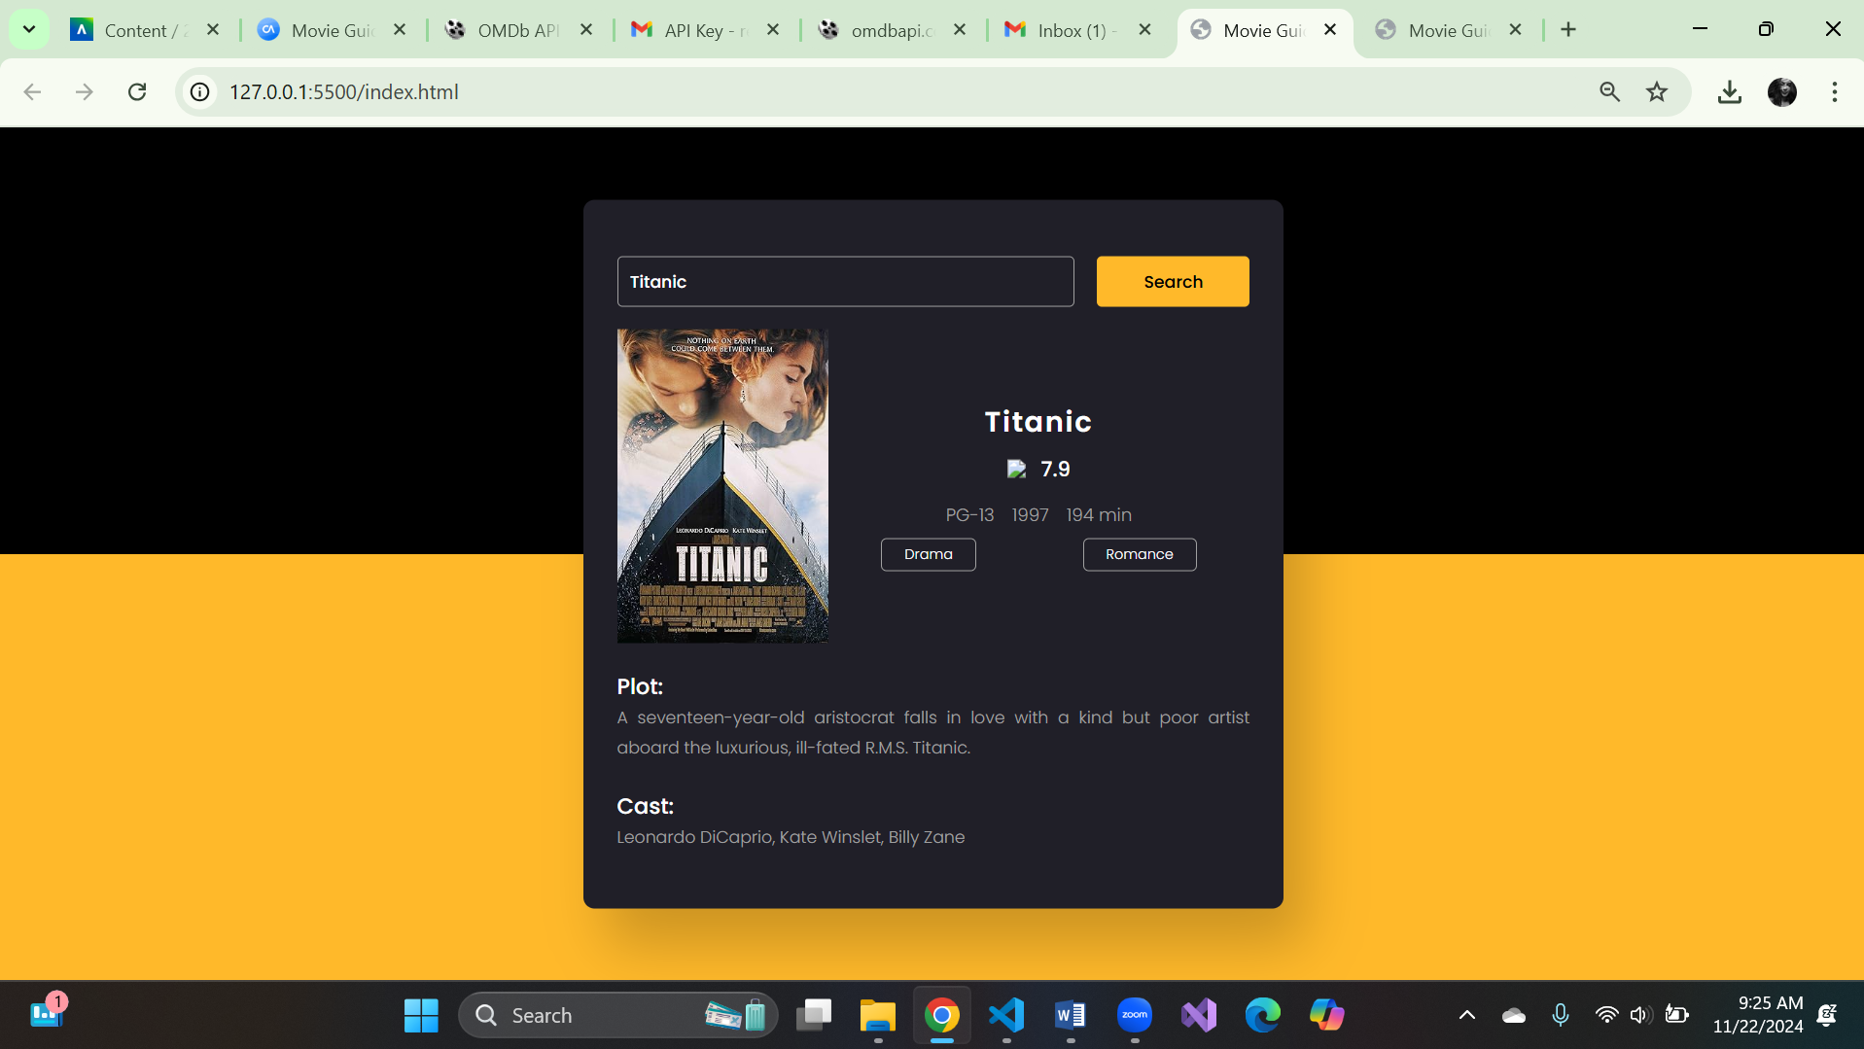

1. **Tic Tac Toe Game**

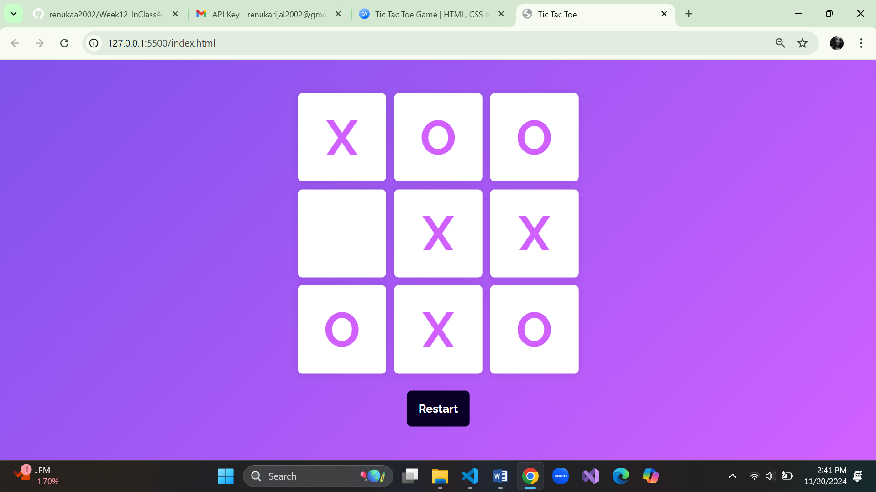

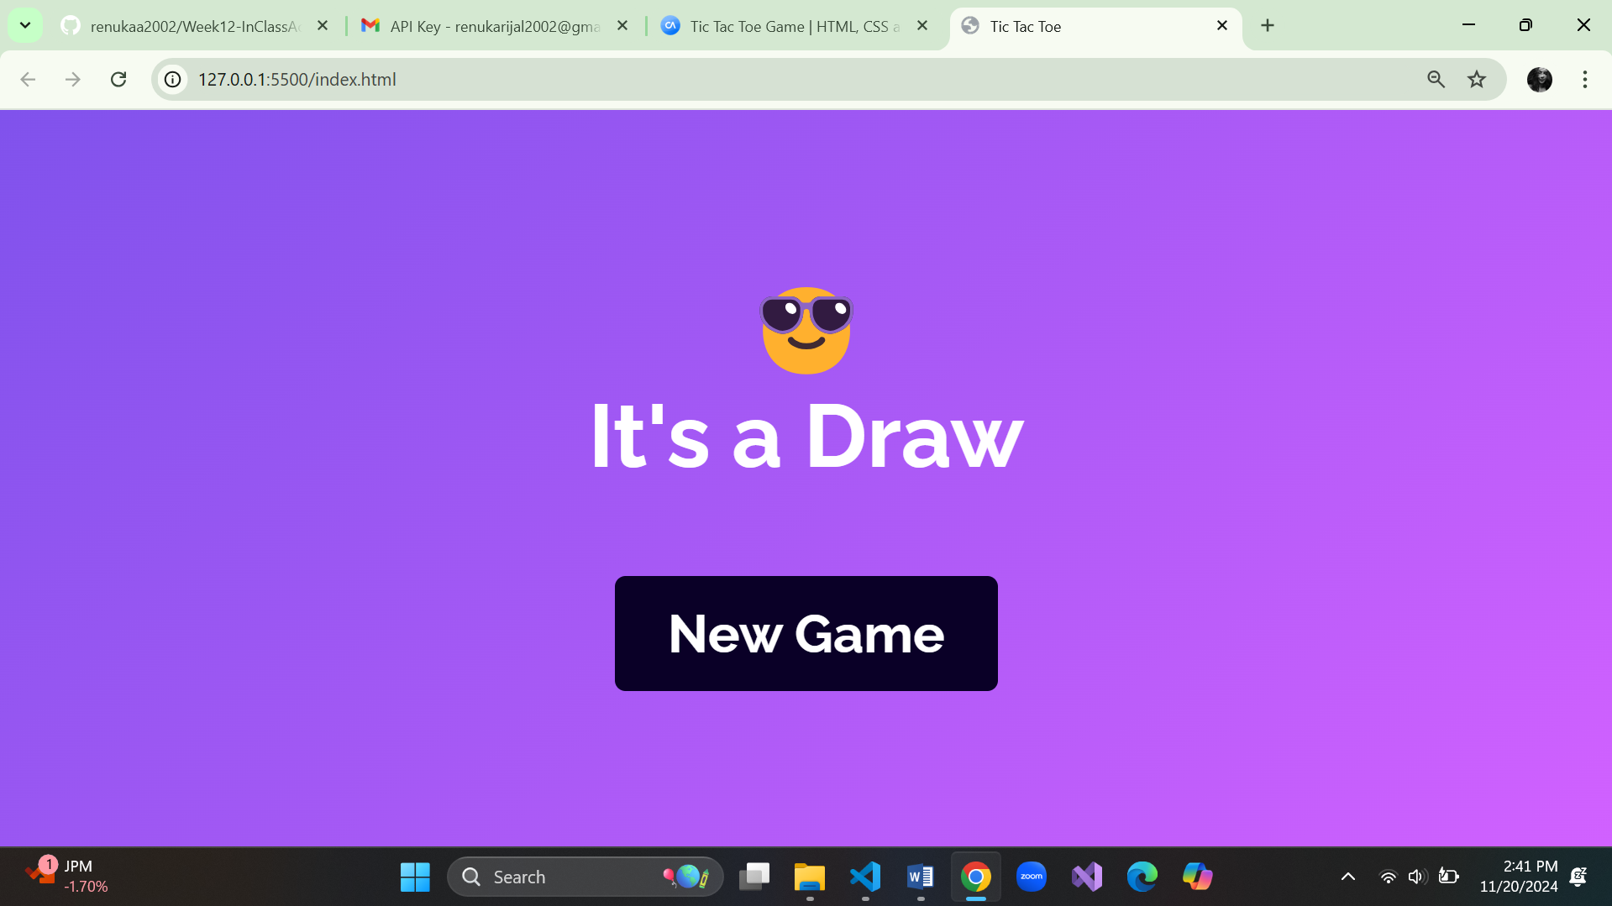

1. **Weather App API**

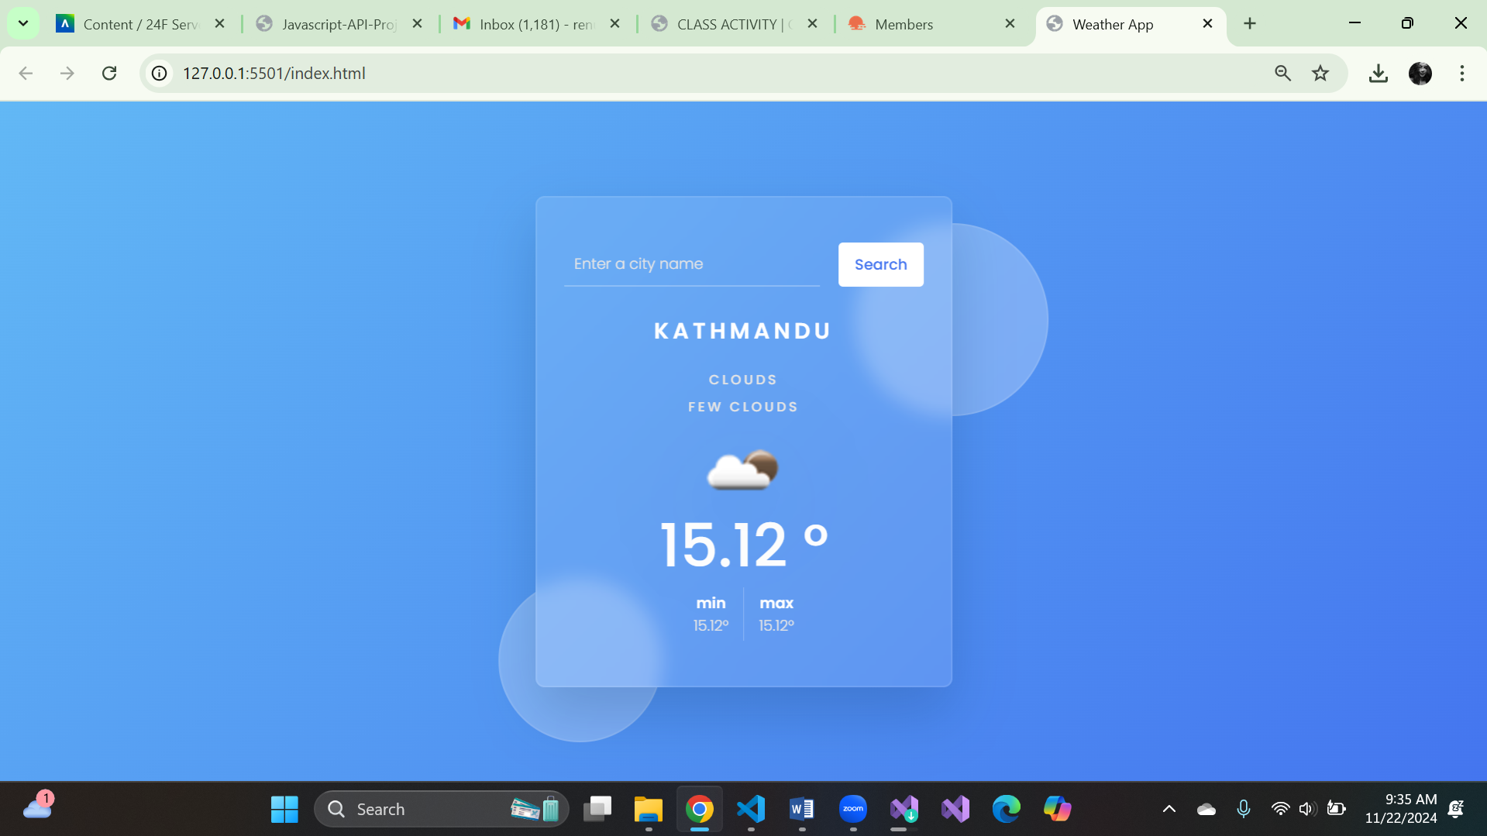

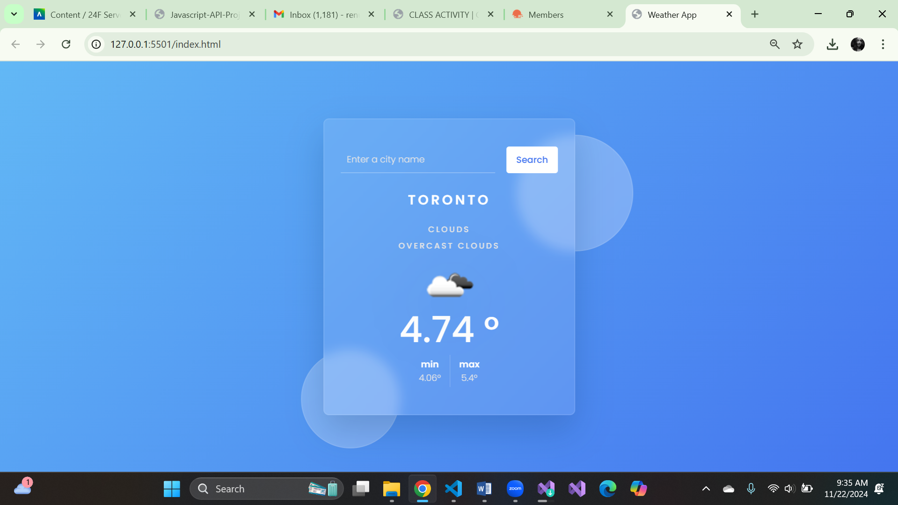

1. **Marvel App API**

* Key not working.